EXPERIMENT :24

# AIM: TO Control of Fan, Light, Window & Application of Using Cisco Packet Tracer

# REQUIREMENTS:

*home gateway

*fan,light,window,purifier,

*smart phone

# PROCEDURE:

-The IoE Things can register directly with the IoE service on a Home gateway or network database. The Home Gateway offers 4 Ethernet ports and a wireless contact point on channel 6 equipped with the SSID [16] "Home Gateway." It is possible to configure WEP / WPA-PSK / WPA2 companies to wireless links are safe for connections. Image (1b) displays 7 IOE items connected to a Home Gateway. The home gateway is connected via the WAN Ethernet port [17] on the internet. A home gateway and a web interface it is easy to manage the IOE system. The internal IP address of the Home Gateway (LAN) is 192.168.25.10, but it can be too reached via its IP address in front of the Internet.

the smart objects are associated to the home gateway by Wireless medium and Ethernet cable for local and remote control of smart devices. Home portal also acts as a DHCP server [18] assigns IP addresses to any, connected smart device.

After registering the smart device [19], [20] to the home gateway, the figure above shows that all devices are accessed by legitimate users via the web. Figure 4 shows that seven IOE devices that are legally regulated are registered in the Home gateway, which are controlled by legitimate individuals [21], [22] through the web

# IMPLEMENTATION :

## STEP:1

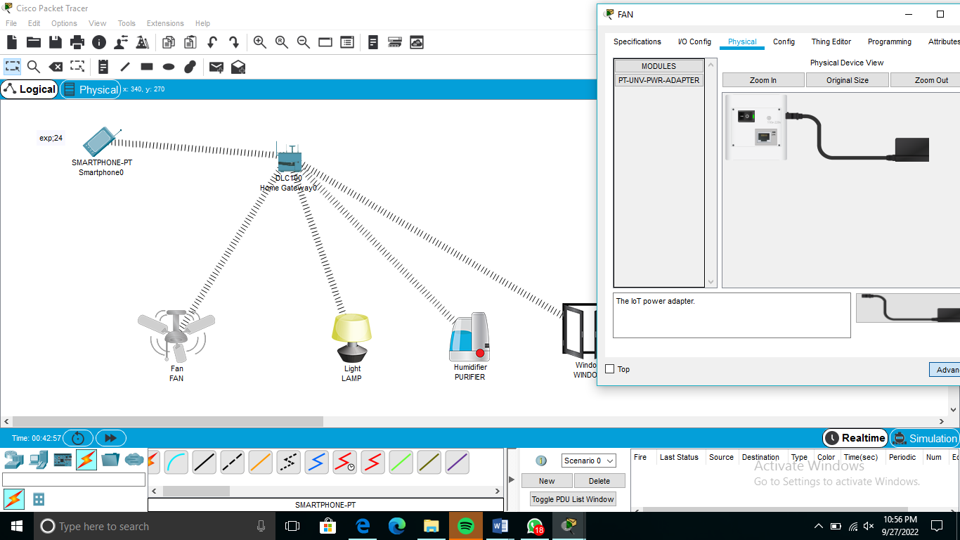

## STEP:2

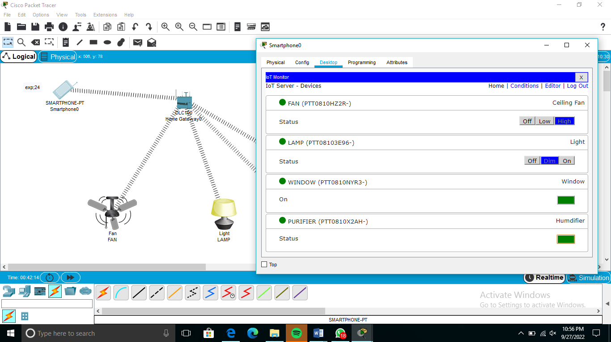

## STEP:3

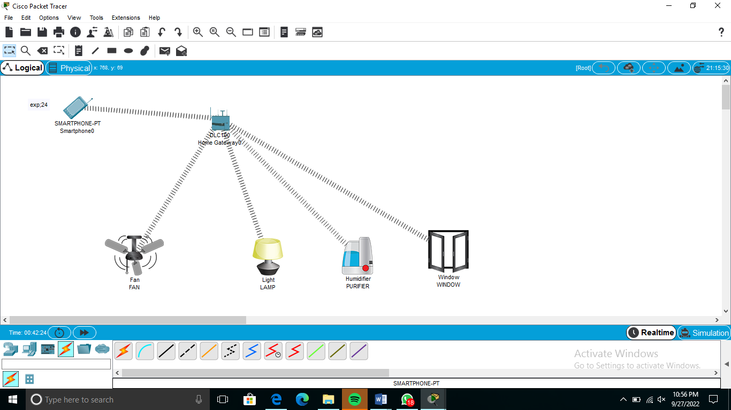

# RESULT:

Hence,this indicates by detecting carbon monoxide and carbon dioxide using a carbon monoxide and lamp , the fan and window are opened.

Thus the was established and the communication

among the machines using ping command is verified successfully